**Hybrid Mobile Project**

**Logo and Wireframes**

**Logo**



*See* [*Capes of Accomplishment*](https://oldschool.runescape.wiki/w/Cape_of_Accomplishment)

**Wireframes (See next page):**

**Splash Screen**

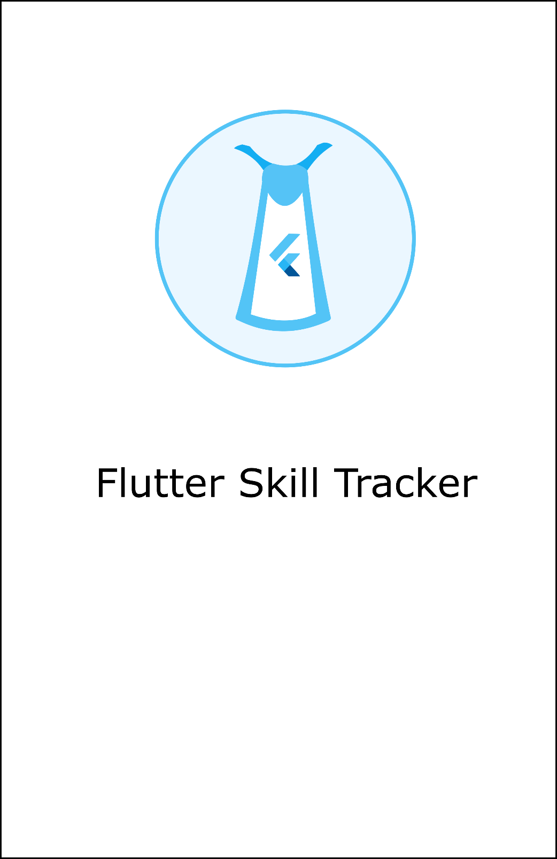

**Player Search**

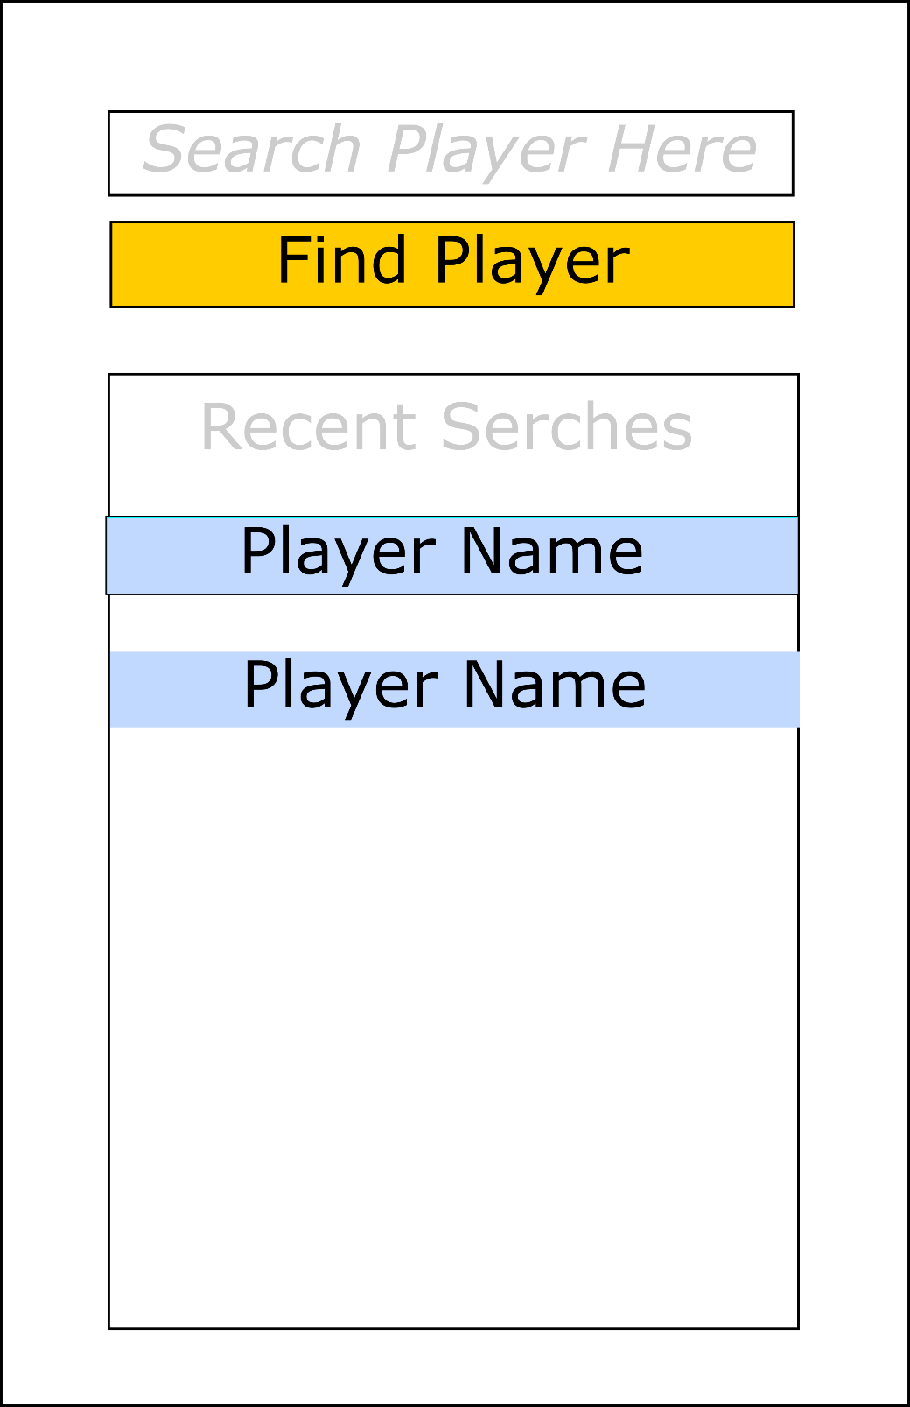

**Player Results**

